“QUICK” REFEREE SNAPSHOT

Name of referee: Relationship ___________Recent appraiser_____

Name of applicant: _________________

School and position: U3 Opononi Area School
Date Quick Referee Report due: 19 February 2024 at 5:00 pm.

This is a very quick referee report to give the Board a snapshot of what they might expect of a full report which is only asked of an applicant who has been shortlisted for an interview. Please save this document to a hard drive, respond to the questions, save it, and then email it as an attachment to Terry Hewetson – terryh@keaeducation.nz.

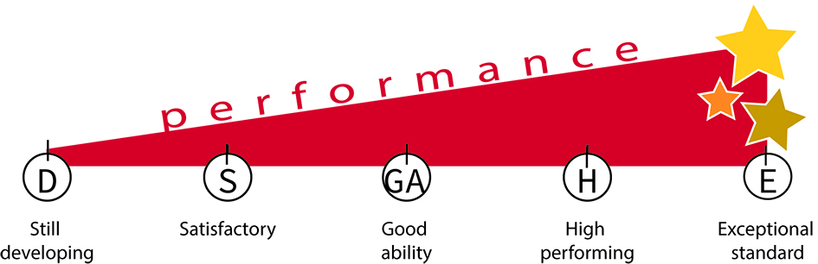
Please write no more than about ten words for each of these topics.
Rating scale is:
E - Exceptional standard
H - High performing
GA - Good ability
S - Satisfactory
D - Still developing

 | Topics | Comment | Rating
1 | Quality of relationships
2 | Quality of leadership
3 | Professional knowledge
4 | Professional skills
5 | Communication skills
6 | Personal and professional ethics.
7 | Knowledge or experience in tikanga.
8 | Reservations (if any)
9 | Your recommendation.
10: Final comments on suitability for our school including cultural appropriateness for our school

